Look at the label name:_____________________
Nutrition information of food labels…
Helps you make __________________ food choices
Helps you follow ________________________________
Is ______________________ on most packaged foods
Is based on Health Canada’s __________________________
Nutrition Claims
What is the difference between Nutrition content claims and health claims?
__________________________________________________________________________________________________________________________________________________________________________
Nutrition Facts Table
Along with the calories in a serving size, which 13 nutrients are included in the nutrition facts table?

- _________________________  - _________________________  - _________________________  - _________________________  - _________________________  - _________________________ | - _________________________  - _________________________  - _________________________  - _________________________  - _________________________  - _________________________  - _________________________

All about Nutrients
Fat
Positive effect: ________________________________________________________________________
Negative effect: ____________________________________________________________
Cholesterol
Positive effect: ________________________________________________________________________
Negative effect: ____________________________________________________________
Sodium
Positive effect: ________________________________________________________________________
Negative effect: ____________________________________________________________
Carbohydrates (two types : ____________________ & _________________________)
Protein
Protein builds your ____________________, ____________________, and _____________________
Vitamins
Vitamin A ____________________________________________
Vitamin C _____________________________________________
Minerals
Calcium may prevent ____________________________
Iron helps your ________________________________ carry __________________ throughout your body.
Take 5 to read the facts
1. Why should you compare the serving size on the package to the amount that you eat?
_____________________________________________________________________________________
2. Calories = _________________________
3. Percent Daily Value tells you if there is a _____________________________________________________________________________________
4. There should be a low % daily value of these three nutrients: ___________________, __________________________, ___________________________
5. There should be a high % of these four nutrients. ___________________, __________________________, ___________________________, ___________________________
Using percent Daily Value (% Daily Value)
Frozen Mixed Vegetables
What is the serving size? ______________________________
What percent Daily Value of sodium does one serving of mixed vegetables have? _______
What nutrient has the highest percent daily value in the frozen vegetables? _______________________
What nutrients does the mixed vegetables not provide? __________________ ( _____________________ + _________________________) , _________________________,
_______________________
What does this tell you about how healthy or unhealthy the food is?
__________________________________________________________________________________________________________________________________________________________________________
Serving up nutrition facts
How is the serving size shown on the nutrition facts tables?
________________________________________: familiar words like ___________ or ______________
________________________________________: Measurements like ___________ and ____________
Cereal example
If you eat 2 cups of cereal
How much fat will you get? ______________________
How many carbs will you ingest? _____________________
What % Daily value of sodium will you ingest? ______________
How much vitamin C will you get? _______________

If you eat ½ of cereal
How much protein will you get? ___________________
How much sodium will you ingest? ___________________
What % daily value of fibre will you get? _________________
All about carbohydrate
The cabs you eat turn to _______________________ in your body in order to provide ou with ________________________.
Why should people with diabetes be concerned with carbohydrate intake?
__________________________________________________________________________________________________________________________________________________________________________
Write and draw pictures around the box of 10 food products that supply you with carbohydrates.

Foods that contain carbohydrates

Write either starch, sugar, or fibre next to the following pictures. Fruits and vegetables will have two of the three written next to them.
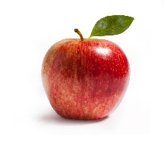_________________________ 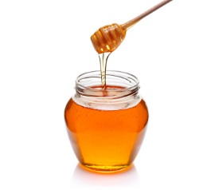___________________________
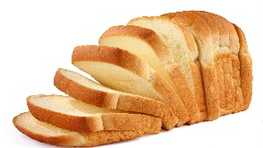 ___________________ 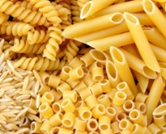 ____________________________
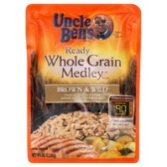 _________________________ 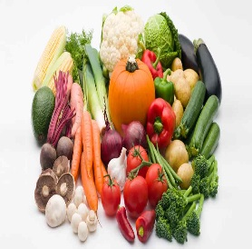_________________________

True or false (carbs and diabetes) Circle T if the statement is true and F if the statement is false.
- Fibre turns into glucose in the blood (T / F )
- Fibre can affect glucose levels (T / F )
- Fibre is a good nutrient (T / F )
- Eating high fibre food may lower your blood glucose (T / F )
- Eating high fibre foods will make you feel hungry (T / F )
- People with diabetes should not pay attention to how many carbs they eat in one sitting (T / F )
- Blood glucose levels are regulated by dispersing your carb intake throughout the day (T / F )
- People with diabetes shouldn’t snack (T / F )
- People with diabetes should decide themselves how many carbs they should eat. (T / F )
- Blood glucose levels rise faster when consumed as part of a complete meal. (T / F )

