Once you have created an account, click ‘log’ on the top menu. Please choose a password you will remember and put it in your phone. If you forget your password, you will need to start all over again.
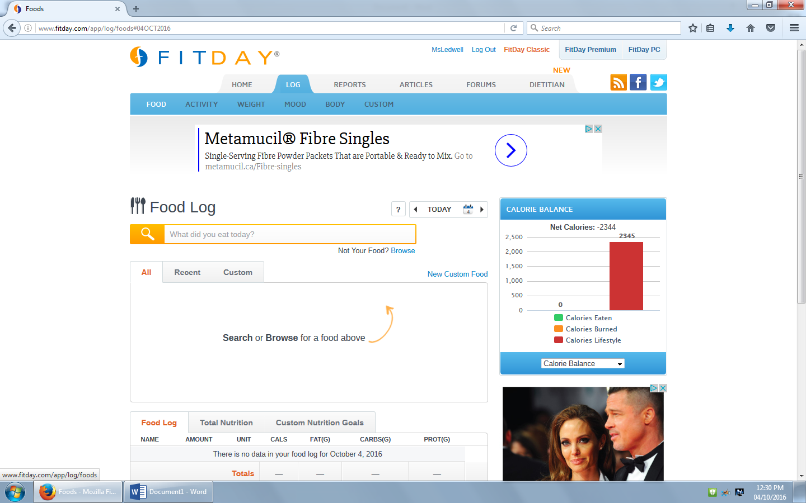

Add something you’ve eaten today. If you’d like to choose another day, click on the calendar to the right of ‘Food Log’
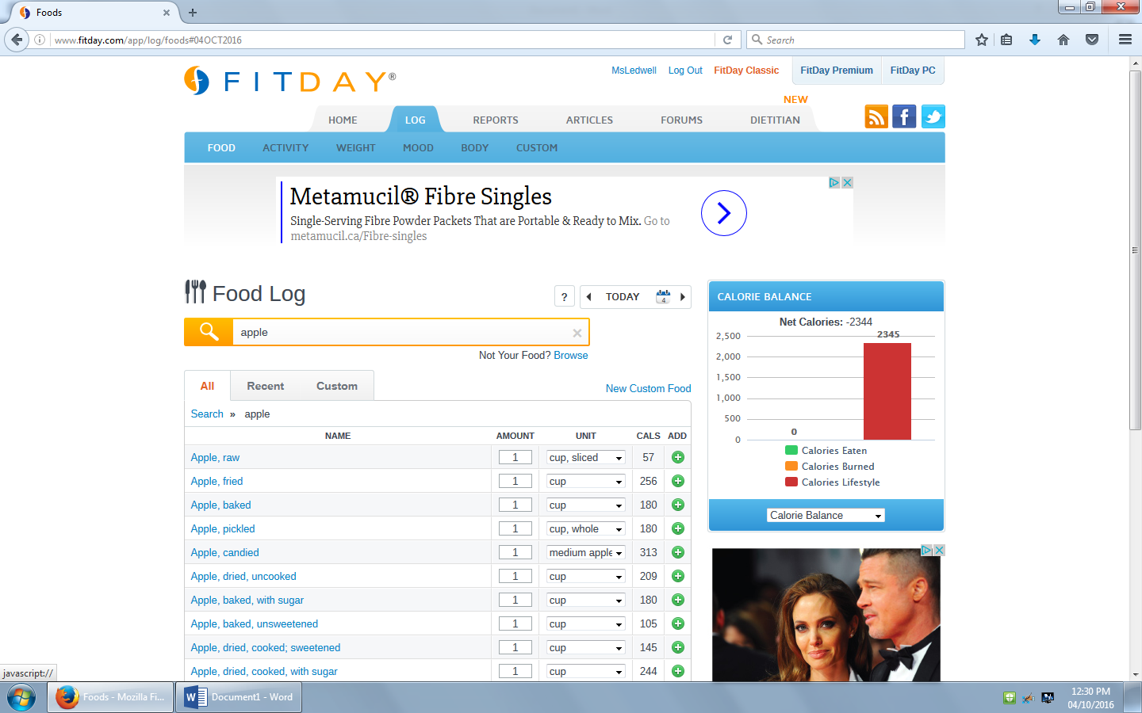

Once you click the green plus sign, the food will be added to you log (see below)

Add what ever else you had to eat that day

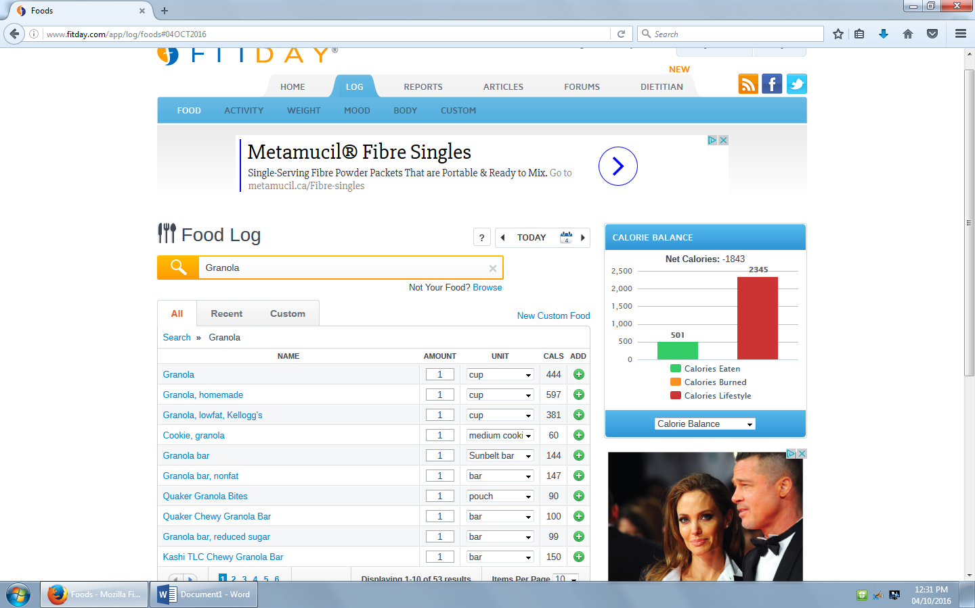
Once you’ve logged food for a day, you will see utensils next to that day on the calendar. Click the utensils to see your food log.
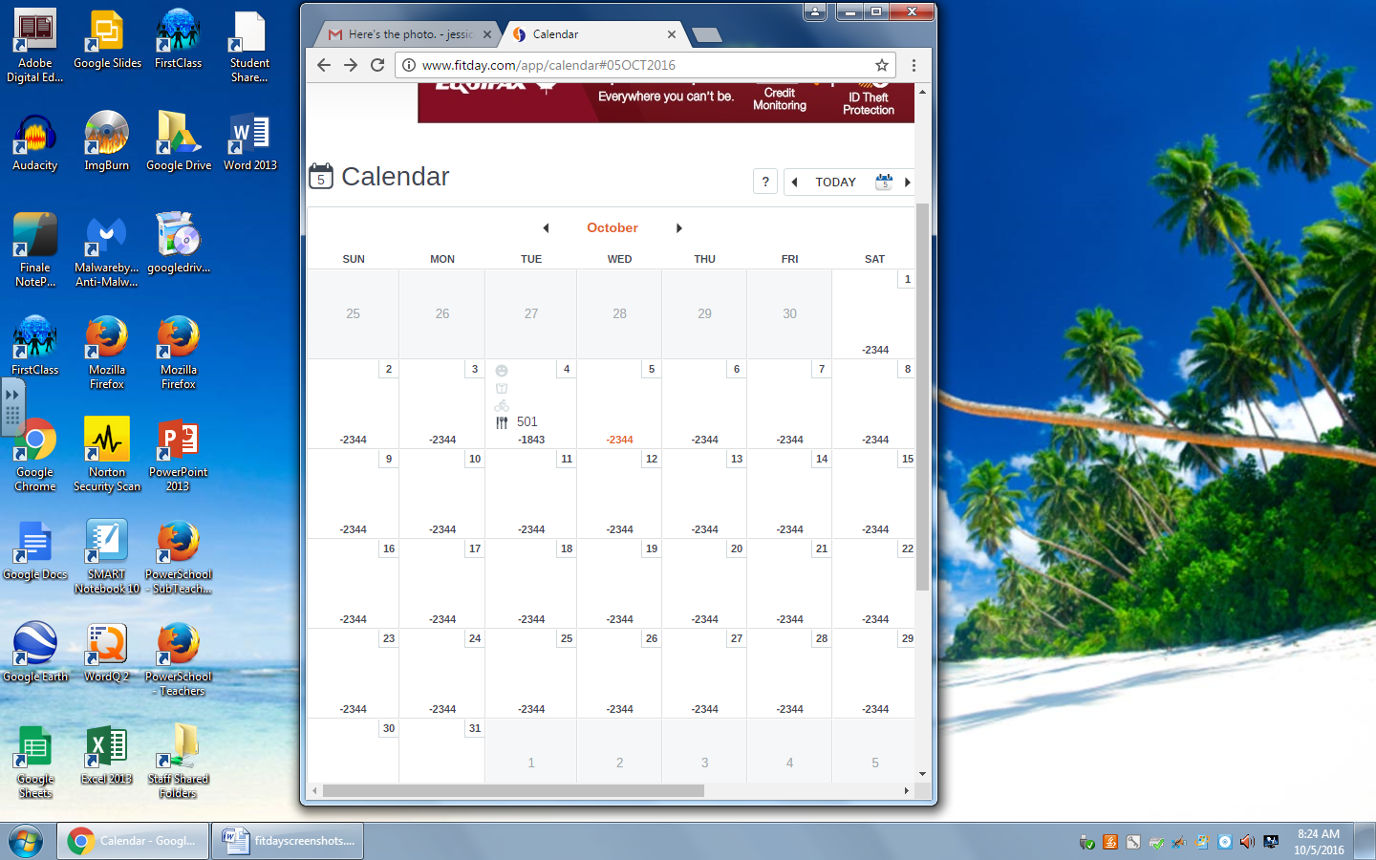
Once you’ve clicked on the utensils, select ‘Calorie Breakdown’ from the scroll down menu that says ‘Calorie Balance’. This will give you the information you require to fill out the table (question #1)
